PLANNING FOR YOUR STUDY IN THE WEEKS PRIOR TO THE IB EXAMS
STEP 3: Plan the weeks before the exams start – the Sept/Oct holidays (cross out the days that you are still at school)
September: the end of term and school holidays | T12 | W13 | T14 | F15 | S16 | S17
M18 | T19 | W20 | T21 | F22 | S23 | S24
M25 HOLIDAYS | T26 | W27 | T28 | F39 | S30 | S1 October
M2 HOLIDAYS | T3 | W4 | T5 | F6 | S7 | S8

STEP 2: List your exams and how many days you had to study for them. See if you are happy for the spread or if you want to do extra for some in the holidays.
Exam | Study Time |  | Exam | Study Time |  | Exam | Study Time |  | Exam | Study Time

STEP 1: Work backwards from your last exam.
M16 Sept: most students still at school this week | T17 | W18 | T19 | F20 | S21 | S22
M23 some schools may not have classes this week | T24 | W25 | T26 | F27 | S28 | S29
M30 Holidays | T1 | W2 October | T3 | F4 | S5 | S6
M7 | T8 | W9 | T10 | F11 | S12 | S13
M14 | T15 | W16 | T17 | F18 | S19 | S20
M21 Exams start | T22 | W23 | T24 | F25 | S26 | S27
M28 | T29 | W30 | T31 | F1 November | S2 | S3
M4 | T5 | W6 | T7 | F8 | S9  EXAMS FINISHED! | S10

OR INSTEAD OF STUDYING 2 SUBJECTS PER DAY IN THE HOLIDAYS, STUDY 2 EXAMS PER DAY:
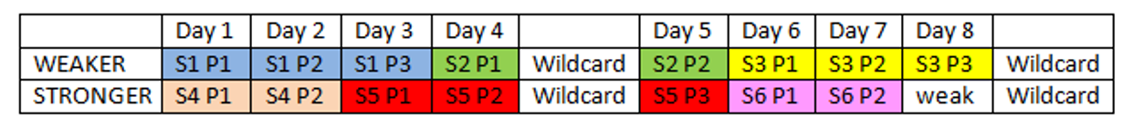
Note:
- Put ‘different’ types of subjects together and do the weakest papers in the morning session
- Do you want to spend equal time on all subjects? Do some need more?

 | Day 1 | Day 2 | Day 3 | Day 4 | Day 5 | Day 6 | Day 7 | Day 8 | Day 9 | Day 10 | Day 11
Weaker subject |  |  |  |  | WILDCARD |  |  |  |  |  | WILDCARD
Easier subject |  |  |  |  | WILDCARD |  |  |  |  |  | WILDCARD

DECISIONS TO MAKE ABOUT THE WEEKS BEFORE THE FIRST EXAM

- How many hours of study do you want to do per day when you aren’t having classes? _____

- What will be your timeslots for each day, how will you structure your day? Some examples are listed below, but what will you do?
Some examples of how you might structure your day:
6 hours per day | 6 hours per day | 8 hours per day | 8 hours per day | 7 hours per day | Your starting point timeslots:
9-12 subject 1  2-5 subject 2 | 10-12 subject 1  2-4 subject 2  6-8 choose 1 or 2 | 9-12 subject 1  2-5 subject 2  7-9 choose 1 or 2 | 9-11 subject 1  12-2 subject 2  4-6 subject 1  7-9 subject 2 | 9-10 review  11-2 subject 1  3-6 subject 2
Note:
- Start by 10am at the latest so your sleep patterns don’t get thrown out
- Great for memory if you spend an hour in the morning reviewing what you did the previous day
- Choose a minimum amount of time and if you do more that’s great. Many students aim for 6 hours and do more if they can.

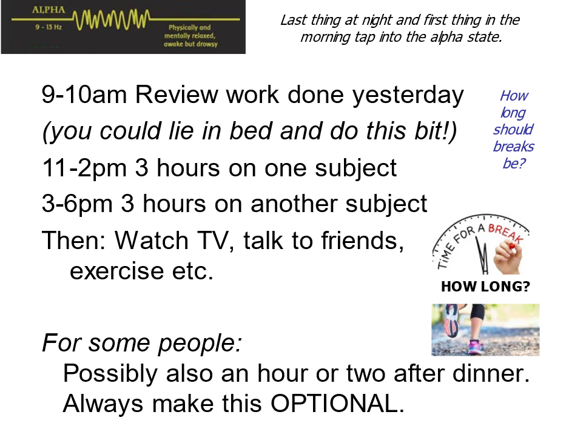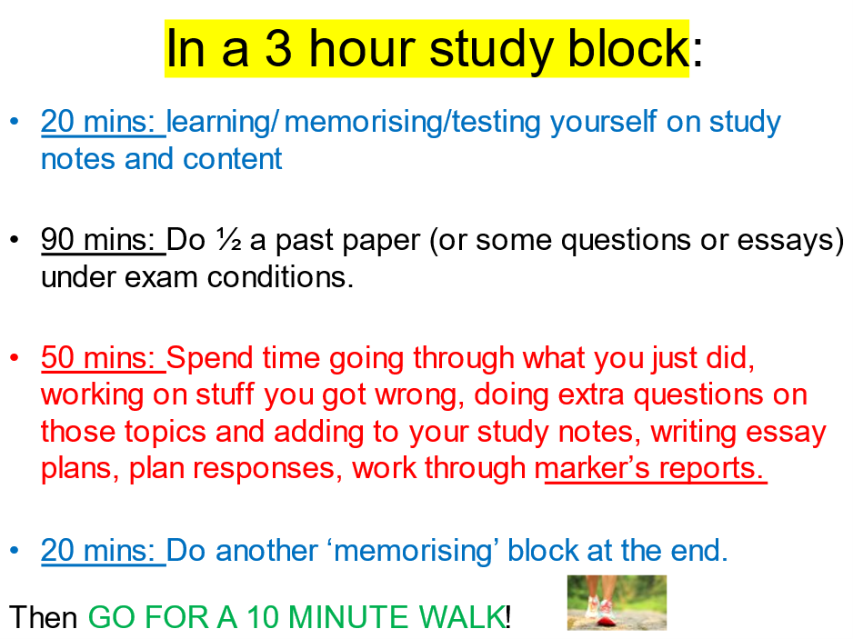

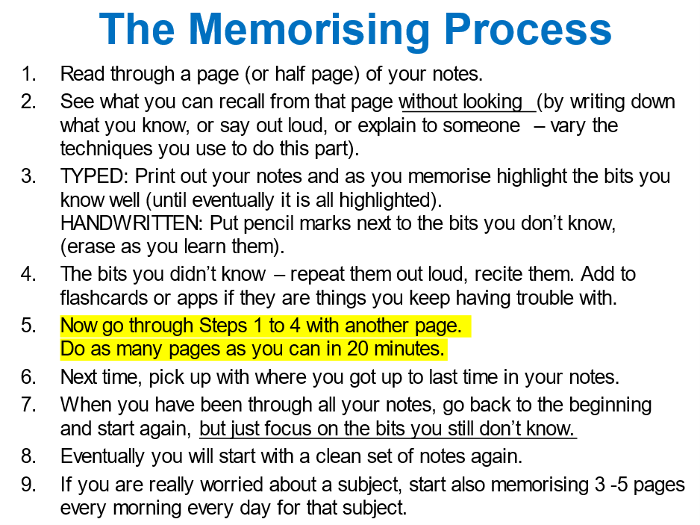 | Your notes:

SUBJECT AUDIT

SUBJECT:
What do you want to get done for this subject by the end of term?

Feedback?
Study notes?
Spot revision?
Chapter reviews?
Essays?

PLANNING STUDY FOR THE REST OF THE TERM WHILE AT SCHOOL: During the week allocate 1 or 2 subjects to focus on each night and 2-3 per day on the weekend.
Cross out any days that you are on holidays. This section is just focusing on term time.

M14 August | T15 | W16 | T17 | F18 | S19 | S20
M21 | T22 | W23 | T24 | F25 | S26 | S27
M28 | T29 | W30 | T31 | F1 September | S2 | S3
M4 | T5 | W6 | T7 | F8 | S9 | S10
M11 | T12 | W13 | T14 | F15 | S16 | S17
M18 | T19 | W20 | T21 | F22 | S23 | S24

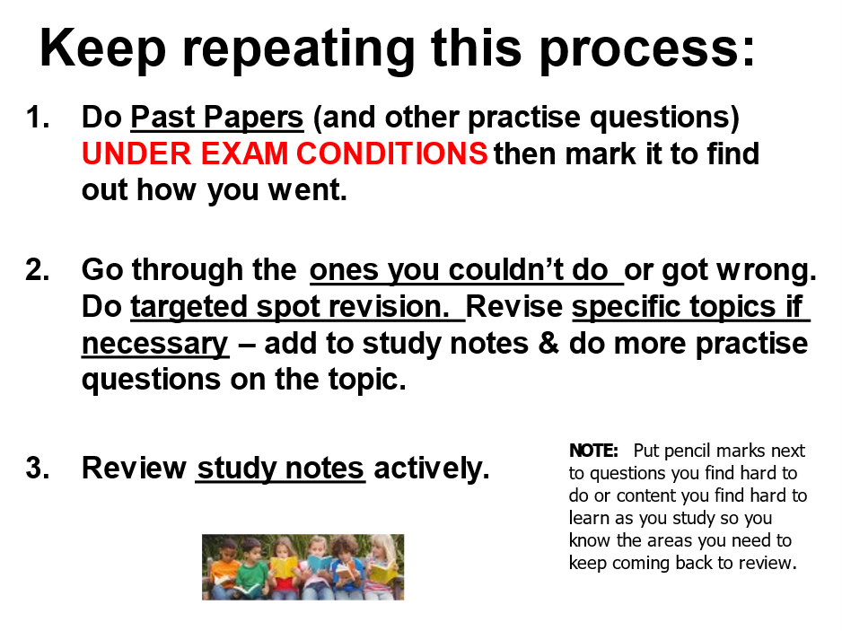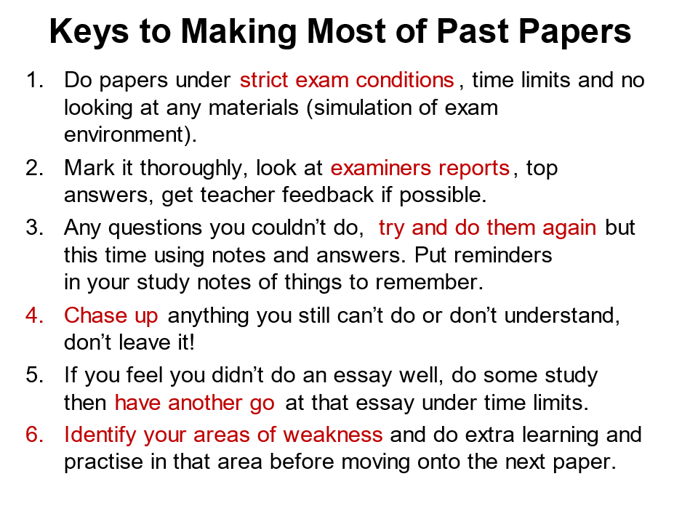

At the end of the term, do a new subject audit. What do you want to get done in the holidays before the exams start?

SUBJECT AUDIT FOR THE HOLIDAYS

SUBJECT:
What do you want to get done for this subject before the exams start

How many essays? Past papers? What other revision? Specific topic revision?

SLIDES: https://enhanced-learning.net/eles/slides.html find Year 12 at the bottom of the page, password: success
Extra resources: www.studyskillshandbook.com.au if your school subscribes

